*Shelli Johnson*

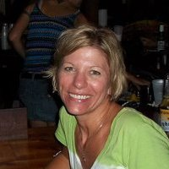Raised in rural Illinois, I first discovered art through an inspirational junior high art teacher. The sciences called though, and I dabbled in Anthropology and Medical Laboratory Sciences, collecting a few undergraduate degrees along the way, until finally heeding the call of the ocean and returning to school for a master’s degree in Marine Biology. Over the course of nearly twenty years, I built a career in marine sciences in the Florida Keys; teaching about, protecting, and managing the marine resources I so cherished.

During this time, I rediscovered the joy of painting, and was able to blend it with my love of the ocean. My art took a backseat to my career for those two decades, but with renewed inspiration, it has recently moved to the forefront. Working in both acrylic and oil, and often incorporating recycled found materials into my handmade frames, my subject focus has shifted from the tropical seascape of the Florida Keys to the life and landscape of coastal North Carolina and the Outer Banks, where I’ve lived with my wife and young daughter since 2019.

There is beautiful scenery over every dune of the Outer Banks; and with just enough of a taste of the seasons of my midwestern childhood, combined with an island life vibe that shaped so much of my adulthood, there is no more perfect place to call home. With my art, I hope to capture small pieces of the magic of this very special place. You can find my work at Artsy Octopus in Nags Head, in the Dare Arts Gallery in Manteo, on Facebook at Shelli Johnson Art, or by contacting me directly at ShelliJohnsonArtOBX@gmail.com.

