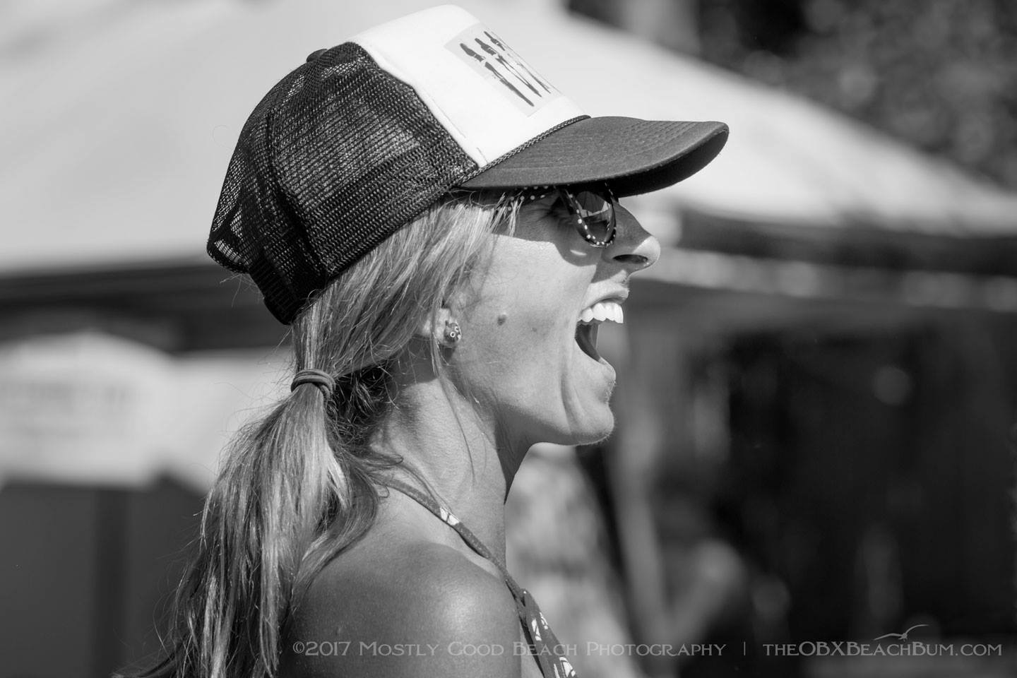

Meg Rubino is a painter from Kitty Hawk, North Carolina. She graduated from Bucknell University with a major in Elementary Education and a minor in painting. After teaching for three years, she returned to East Carolina University to continue her education in Studio Art. She permanently moved to the Outer Banks in 2003 and began her art career. Meg paints in watercolor and acrylic. She is inspired daily by the natural beauty of the Outer Banks and attempts to capture the good feelings the surroundings evoke in her paintings. She also loves traveling to other coastal towns to capture the local color. Meg participates in local art shows. Her work can also be found at galleries, restaurants, and businesses along the Outer Banks including the KDH Cooperative, Dare County Arts Council, Trio, Outer Bean, Rundown Café, Blue Moon Restaurant, Blue Water Bar and Grill, Miller’s Restaurant, First Bank, The Spot, Corolla Wild Horse Adventures, Corolla’s Kind Cup, Urban Cottage, Island Attic Avon location, Pea Island Art Gallery, and Bella Fiore in Ocracoke. “I hope my work makes you feel good and inspires you to embrace the little joys you experience daily.” If you wish to check out more of my art, I have an art Instagram page @yellowsolstudio. You can also contact me through my email, meganrubino@yahoo.com, with any questions or inquiries.